**Power BI Inflation Analysis: Journeying**

**Through Global Economic Terrain**

**Team ID:PNT2025TMID07069**

**Team Members:**

CH. BHARATH(22FE5A0320)

B.RAMESH (22FE5A0309)

B. SAIADTHYA (22FE5A0313)

CH.GOPIKRISHNA (22FE5A0319)

**CONTENT**

1.INTRODUCTION

1.1 Project Overview

1.2 Purpose

1. IDEATION PHASE
   1. Problem Statement
   2. Empathy Map Canvas
   3. Brainstorming
2. REQUIREMENT ANALYSIS
   1. Customer Journey map
   2. Solution Requirement
   3. Data Flow Diagram
   4. Technology Stack
3. PROJECT DESIGN
   1. Problem Solution Fit
   2. Proposed Solution
   3. Solution Architecture
4. PROJECT PLANNING & SCHEDULING
   1. Project Planning
5. FUNCTIONAL AND PERFORMANCE TESTING
   1. Performance Testing
6. RESULTS
   1. Output Screenshots
7. ADVANTAGES & DISADVANTAGES
8. CONCLUSION
9. FUTURE SCOPE 11. APPENDIX

Source Code(if any)

Dataset Link

GitHub & Project Demo Link

# INTRODUCTION

## a. Project Overview

Inflation significantly impacts global economies, affecting businesses, consumers, and policymakers. The Power BI Inflation Analysis project aims to provide a comprehensive data-driven approach to analysing inflation trends. This project integrates real-time and historical inflation data, applies predictive modelling, and delivers interactive dashboards to enable businesses and financial analysts to make informed decisions.

**1.2 Purpose**

The key objectives of this project include:

**Enhancing Data-Driven Decisions** – By integrating inflation data from multiple sources, businesses can optimize pricing strategies, mitigate risks, and improve investment outcomes.

**Improving Data Consistency** – Standardizing inflation reporting across various regions ensures accurate comparisons and enhances data reliability.

**Expanding Access to Historical Data** – Incorporating long-term trends helps users understand inflation patterns and develop strategic policies.

**Providing Actionable Insights** – Interactive dashboards visualize inflation trends to aid decisionmaking.

**Increasing Business Confidence** – Organizations can make strategic decisions backed by real-time data visualizations.

**Facilitating Macroeconomic Analysis** – Policymakers and economists can analyse inflation trends across different regions and predict future economic shifts.

**Supporting Financial Planning** – Investors and financial analysts can assess inflation’s impact on stock markets, interest rates, and purchasing power.

**Automating Inflation Reporting** – Reducing manual data processing by generating automated reports for governments, businesses, and research institutions.

**Encouraging Transparency in Economic Data** – Providing publicly accessible dashboards for better economic literacy and awareness.

These enhancements ensure that the Power BI Inflation Analysis project delivers **comprehensive, reliable, and actionable** insights to users across various sectors.

1. **IDEATION PHASE**

a. **Problem Statement**

**Customer Problem Statement Template:**

I am a multinational corporation operating in diverse markets.

I’m trying to make data-driven decisions to optimize pricing strategies, mitigate risks, and enhance investment outcomes.

But I face challenges with inconsistent data integration, limited historical data availability, and complex economic interdependence.

Because different regions report inflation data differently, historical data is scarce, and global economic factors influence each other unpredictably.

Which makes me feel uncertain about making accurate predictions and strategic decisions that align with each market’s economic conditions.

**Example:**

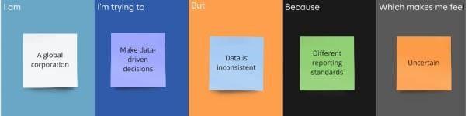

|  |  |  |  |  |  |
| --- | --- | --- | --- | --- | --- |
| **Problem**  **Statement** | **I am**  **(Customer)** | **I’m trying to** | **But** | **Because** | **Which makes me** |
| PS-1 | A  multinational l corporation operating in diverse global markets. | Use inflation data to make smart pricing  and investment decisions. | The data is inconsistent t and hard to analyse. | Different regions report inflation differently, and historical data is often missing. | Uncertain and less confident about decisionmaking. |
| PS-2 | A global retail corporation with operations in many countries. | Understand inflation trends to make pricing and supply chain decisions. | The data is inconsistent t  and hard to compare. | Each country reports inflation differently, and data is often incomplete. | Vulnerable to making bad decisions that could hurt profits. |

**2.2 Empathy Map Canvas**

**Empathy Map Canvas:**

An empathy map is a simple, easy-to-digest visual that captures insights about stakeholders’ perspectives on inflation impacts and economic challenges.

It is a useful tool that helps teams better understand how inflation dynamics affect business strategies and decision-making. Creating an effective inflation strategy requires understanding the real economic issues and the perspectives of those who are impacted. The exercise of creating the map helps participants consider inflation effects from the viewpoint of various stakeholders, including their goals, challenges, and responses to economic shifts.

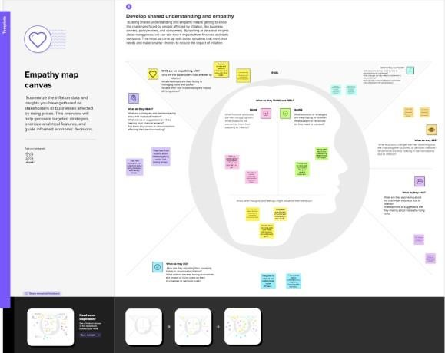

Reference:[click her e t o chec k mor e in detai](https://app.mural.co/t/dataanalysis1412/m/dataanalysis1412/1742572535512/1186656ffc5adb51df5180840b1a26eaf481a855)  [l](https://app.mural.co/t/dataanalysis1412/m/dataanalysis1412/1742572535512/1186656ffc5adb51df5180840b1a26eaf481a855)

**2.2 Brainstorming**

**Brainstorm & Idea Prioritization Template for Power BI Inflation Analysis:**

Brainstorming is an essential part of analyzing global inflation trends and developing datadriven insights for multinational corporations. This process encourages team members to share creative ideas and practical solutions, focusing on exploring diverse perspectives to tackle challenges related to data integration, historical data accessibility, and complex economic interdependencies.

By fostering an open and collaborative environment, team members can freely discuss potential approaches and share innovative techniques to improve data accuracy and visualization in Power BI dashboards. Out-of-the-box thinking is highly valued, as it helps uncover unique solutions that might otherwise be overlooked.

Reference:[click her e](https://app.mural.co/t/dataanalysis1412/m/dataanalysis1412/1742492697379/a86bce032d9261efa19be1d0288acb62d65a09e8)

**Step-1: Team Gathering, Collaboration and Select the Problem Statement**

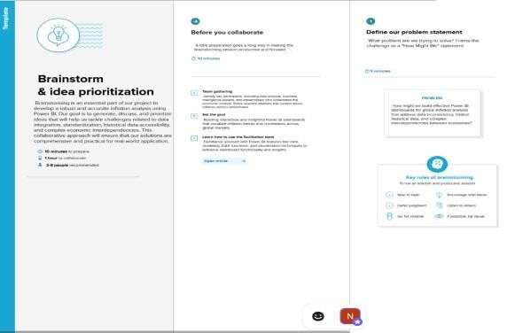

**Step-2: Brainstorm, Idea Listing and Grouping**

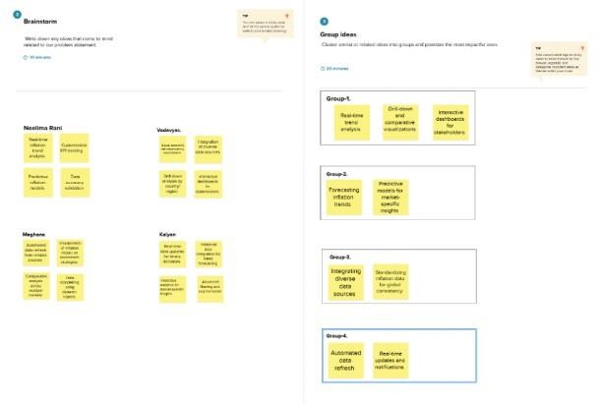

**Step-3: Idea Prioritization**

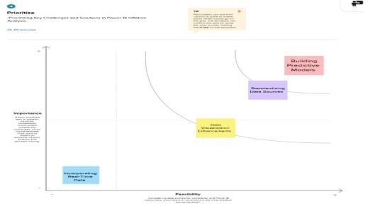

1. **REQUIREMENT ANALYSIS** 
   1. **Customer Journey map**

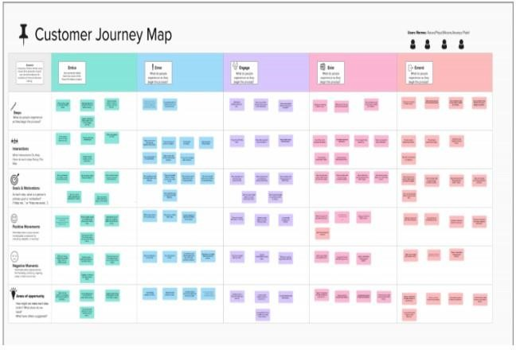

Reference::[Click Here](https://app.mural.co/t/neelima8405/m/neelima8405/1742801093808/bab2e9330b0cd3287b7aba0cd0dbeb02155847c0)

* 1. **Solution Requirement**

**Functional Requirements:**

Following are the functional requirements of the proposed solution.

|  |  |  |
| --- | --- | --- |
| **FR No.** | **Functional Requirement** | **Sub Requirement (Story / Sub-Task)** |
| FR-1 | **(Epic)**  Data Collection | Collect inflation data from multiple reliable sources |
| FR-2 | Data Standardization | Convert data formats to ensure uniformity  Handle missing or inconsistent data |
| FR-3 | Data Visualization | Build interactive dashboards to display inflation trends |
| FR-4 | Data Reporting | Generate automated reports summarizing inflation insights |

**Non-functional Requirements:**

Following are the non-functional requirements of the proposed solution.

|  |  |  |
| --- | --- | --- |
| **FR No.** | **Non-Functional Requirement** | **Description** |
| NFR-1 | **Usability** | The dashboard should have an intuitive and userfriendly interface for effortless navigation and data |
| NFR-2 | **Security** | ti Ensure secure access with role-based  authentication and data encryption to protect |
| NFR-3 | **Reliability** | iti i f  The system should provide accurate and  ti  consistent results without unexpected  failures or |
| NFR-4 | **Performance** | t l  he dashboards should load and update data efficiently, even with large datasets, to maintain |
| NFR-5 | **Availability** | i  The system should be available 24/7 to allow users to access real-time insights at any given |
| NFR-6 | **Scalability** | ti  The solution should be able to handle increasing data volume and additional features without |

f d d ti

* 1. **Data Flow Diagram**

**Data Flow Diagrams:**

A Data Flow Diagram (DFD) is a traditional visual representation of the information flows within a data analysis system. In the context of our Power BI Inflation Analysis project, a neat and clear DFD can graphically depict the flow of inflation data, from data collection and preprocessing to visualization and report generation. It shows how inflation data is gathered from various sources, processed, analyzed, and transformed into interactive dashboards, providing valuable insights for strategic decision-making.

**Example of Data Flow Diagram:**

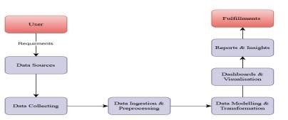

**User Stories**

Use the below template to list all the user stories for the product.

|  |  |  |  |  |  |  |
| --- | --- | --- | --- | --- | --- | --- |
| **User Type** | **Functional**  **Requirement**  **(Epic)** | **User**  **Story**  **Number** | **User Story / Task** | **Acceptance**  **criteria** | **Priority** | **Release** |
| Data  Analyst | Data Collection | USN-1 | .As a data analyst, I can collect inflation data from various sources to ensure  comprehensive analysis | I can access complete and accurate inflation data. | High | Sprint-1 |
|  | Data  Standardization | USN-2 | As a data analyst, I will receive standardized data that is consistent across different sources | I can work with uniform data for  reliable analysis. | High | Sprint-1 |
|  | Data  Visualization | USN-3 | As a data analyst, I can visualize inflation trends using interactive dashboards. | I can view clear and insightful visualizations of  inflation data. | Medium | Sprint-2 |
|  | Data Reporting | USN-4 | As a data analyst, I can  generate comprehensive reports on inflation  trends and predictions.l | I can produce reports that summarize key findings and insights. | Medium | Sprint-1 |
| Business  User | Dashboard  Access | USN-5 | As a business user, I can log into the dashboard to view inflation analysis and insights. | I can easily navigate and interact with the dashboard. | High | Sprint-1 |

**3.4 Technology Stack**

**Technical Architecture:** The Deliverable shall include the architectural diagram as below and the information as per the table1 & table 2

### Example: Inflation Data Analysis Workflow in Power BI

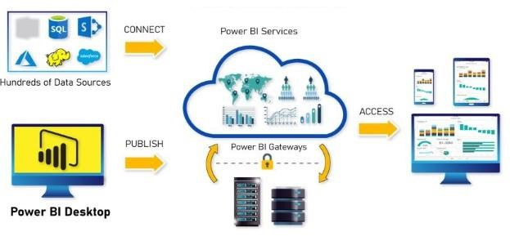

|  |  |  |  |
| --- | --- | --- | --- |
| **S.No** | **Component** | **Description** | **Technology** |
| 1. | User Interface | How users interact with the dashboards and reports. | Power BI Desktop,  Power BI Service |
| 2. | Data Sources | Data input for analysis. | Excel, SQL, CSV, JSON |
| 3. | Data Transformation | Data cleaning, shaping, and transformation. | Power Query, DAX |
| 4. | Data Modelling | Establishing relationships between tables. | Power BI Data Model |
| 5. | Visualization Layer | Displaying data through charts and visuals. | Power BI Visualizations,  Custom Visuals |
| 6. | Cloud Service | Publishing and sharing reports online. | Power BI Service,  OneDrive |
| 7. | File Storage | Storing project files and datasets. | Local Filesystem,  OneDrive |
| 8. | External API-1 | API used for fetching real-time inflation data. | Inflation Rate API (e.g.,  FRED API) |
| 9. | External API-2 | API for currency exchange rates. | Exchange Rate API |
| 10. | Machine Learning  Model | Model for predictive inflation trends. | Azure Autum, Python  Integration |
| 11. | Infrastructure (Server /  Cloud) | Deployment and hosting platform. | Microsoft Azure, Cloud Storage |

**Table-2: Application Characteristics:**

|  |  |  |  |
| --- | --- | --- | --- |
| **S.No** | **Characteristics** | **Description** | **Technology** |
| 1. | Open-Source  Frameworks | Frameworks used for data processing. | Python (Pandas, NumPy),  R |
| 2. | Security  Implementations | Data encryption and access control. | Row-level security (RLS),  IAM |
| 3. | Scalable Architecture | Ensuring Scalability with larger data sets. | Power BI Premium, Azure  Synapse |
| 4. | Availability | Ensuring availability of reports and dashboards. | Power BI Service with  Auto-refresh |
| 5. | Performance | Optimizing performance with caching and tuning. | Power BI Aggregations,  Dataflows |

# 4.PROJECT DESIGN

**4.1 Problem Solution Fit**

**Problem – Solution Fit Template:**

The Problem-Solution Fit ensures that the solution effectively addresses the customer’s problem. It helps business analysts, data professionals, and corporate decision-makers identify behavioural patterns and understand the effectiveness of their solutions.

**Purpose:**

1. Enable data-driven decisions to optimize pricing strategies, mitigate risks, and enhance investment outcomes.
2. Improve consistency in data integration and expand access to historical data
3. Provide actionable insights to address the challenges of complex economic interdependence
4. Standardize regional inflation data reporting to enhance accuracy and comparability.
5. Increase business confidence by supporting strategic decisions with comprehensive ,real-time data visualization.

**Template:**

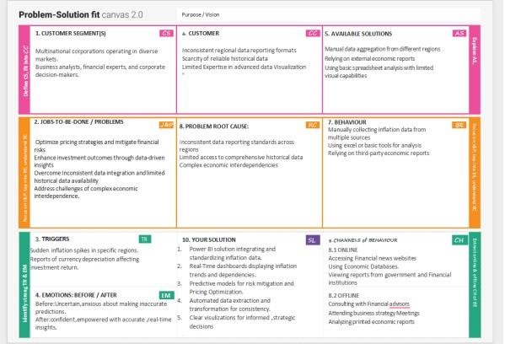

**4.2 Proposed Solution**

Project team shall fill the following information in the proposed solution template.

|  |  |  |
| --- | --- | --- |
| **S.No.** | **Parameter** | **Description** |
| 1. | Problem Statement (Problem to be solved) | The Corporation struggles with inconsistent data integration ,limited historical data ,and complex economic interdependence, making |

1. Idea / Solution description Develop a power BI solution to integrate and standardize inflation data, visualize trends and enhance predictive insights for strategic
2. Novelty / Uniqueness Combines real time dashboards, automated

data extraction, and predictive modelling to

create dynamic and insightful visualizations

1. Social Impact / Customer Enables better pricing strategies, risk

Satisfaction mitigation, and investment decisions, leading

to improved market adaptability and

Solution architecture is a complex process – with many sub-processes – that bridges the gap between business problems and technology solutions. Its goals are to:

Find the best tech solution to solve existing business problems.

Describe the structure, characteristics, behaviour, and other aspects of the Power BI solution to project stakeholders.

Define features, development phases, and solution requirements. Provide specifications according to while

**Solution Architecture Diagram:**

5.

Business Model (Revenue Model)

Lever

ages data analytics as service model to offer

insights and decision

-

making

tools, enh

ancing

profit

ability through data

-

6.

Scalability of the Solution

The solution i

s scalable to include additional economic

indicators, global

regions ,and custom

m

etrics, supporting

future business

**4.3**

**Solution Architecture:**

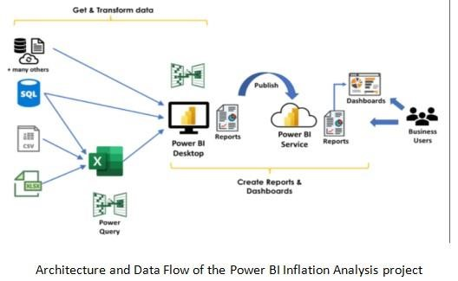

# 5.PROJECT PLANNING & SCHEDULING

**5.1 Project Planning**

**Project Planning Template (Product Backlog, Sprint Planning, Stories, Story points)** template to create product backlog and sprint schedule

|  |  |  |  |  |  |  |
| --- | --- | --- | --- | --- | --- | --- |
| **Sprint** | **Functional**  **Requirement** | **User**  **Story** | **User Story / Task** | **Story**  **Points** | **Priority** | **Team**  **Members** |
| Sprint-1 | Data  Collection | USN-1 | As a User,I can collect  inflation data from | 2 | High | Team  Members |
| Sprint-1 | Data  Preprocessing | USN-2 | As a user , I can clean and standardize data for | 1 | High | Team  Members |
| Sprint-1 | Data  Integration | USN-3 | As a user, ,I can  Integrate datasets from | 2 | Low | Team  Members |
| Sprint-2 | Data  Visualization | USN-4 | As a user, I can view  inflation trends on | 2 | Medium | Team  Members |
| Sprint-2 | Predictive Modeling | USN-5 | As a user, I can apply Forecasting models to | 1 | High | Team  Members |
| Sprint-2 | Dashboard | USN-6 | As a user,I can generate reports summarizing | 3 | High | Team  Members |

**Project Tracker, Velocity & Burndown Chart: (4 Marks)**

|  |  |  |  |  |  |  |
| --- | --- | --- | --- | --- | --- | --- |
| **Sprint** | **Total Story**  **Points** | **Duration** | **Sprint Start**  **Date** | **Sprint End Date**  **(Planned)** | **Story Points Completed (as on Planned**  **End Date)** | **Sprint Release**  **Date (Actual)** |
| Sprint-1 | 30 | 14 Days | 31 Jan  2025 | 13 Feb 2025 | 30 | 13 Feb 2025 |
| Sprint-2 | 30 | 14 Days | 14 Feb 2025 | 28 Feb 2025 | 30 | 28 Feb 2025 |

**Velocity:**

Imagine we have a 10-day sprint duration, and the velocity of the team is 20 (points per sprint).

Let’s calculate the team’s average velocity (AV) per iteration unit (story points per day  **AV=Total Story Points /Sprint Duration= 30/14 =2.14**  **Burndown Chart:**

A burn down chart is a graphical representation of work left to do versus time. It is often used in agile [softwar e develo pment m](https://www.visual-paradigm.com/scrum/what-is-agile-software-development/)ethodologies such as [Scrum.](https://www.visual-paradigm.com/scrum/scrum-in-3-minutes/) However, burn down charts can be applied to any project containing measurable progress over time.

# 6. FUNCTIONAL AND PERFORMANCE TESTING

**6.1 Performance Testing**

**Model Performance Testing:**

Project team shall fill the following information in model performance testing template.

|  |  |  |
| --- | --- | --- |
| **S.No.** | **Parameter** | **Screenshot / Values** |
| 1. | Data Rendered |  |  |
| 2. | Data Preprocessing |  |

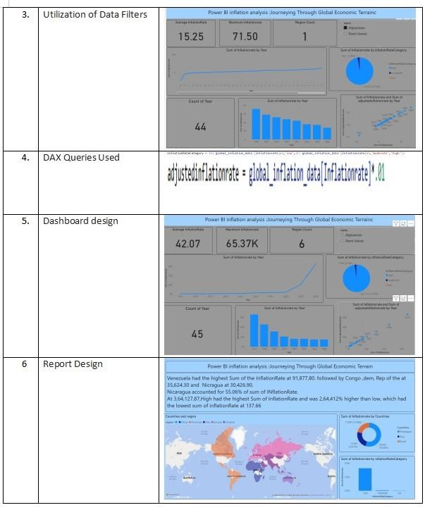

# 7. RESULTS

**7.1 Output Screenshots**

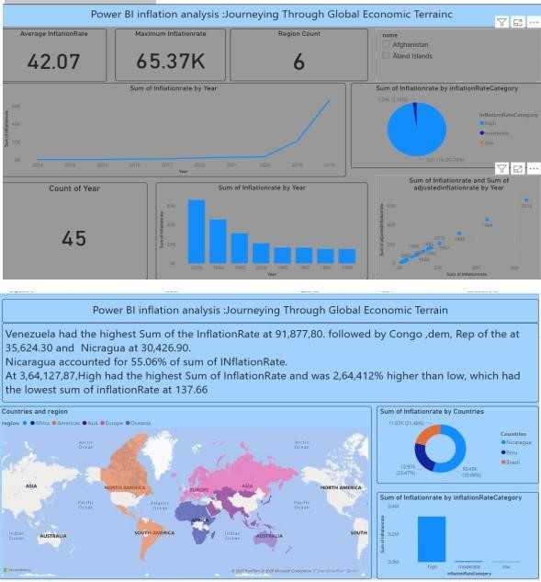**8. \**

## ADVANTAGES

Provides a user-friendly interface for seamless content sharing.

Enhances engagement through interactive features.

Offers data analytics to track performance and audience behaviour.

## DISADVANTAGES

Requires significant infrastructure and maintenance costs.

Faces competition from well-established platforms.

Potential privacy and security concerns for users.

## 9. CONCLUSION

The platform aims to bridge gaps in existing video-sharing services.

Offers unique features tailored for a specific audience.

Provides opportunities for creators and users to engage effectively.

Focuses on user experience to stand out from competitors.

Aims to implement strong security and data protection measures.

Scalability potential to expand features based on user demand.

## 10. FUTURE SCOPE

Integration of AI-driven content recommendations.

Expansion to support multiple languages and regional content.

Enhancement of security measures for user data protection.

Development of interactive and immersive content formats (e.g., AR/VR).

Implementation of blockchain technology for copyright protection.

Improved monetization options for creators, including tipping and premium content.

Collaboration with influencers and brands to increase platform reach.

## 11. APPENDIX

Technical specifications of the platform.

Survey results and user feedback.

References and additional resources.

Comparison with existing video-sharing platforms.

Case studies of successful content creators.

Details on backend architecture and technology stack.